# Week 8 – Homework

Pages 114 – 116 problems #1 - #10

1. The U.S. Trade Deficits for the last half of 1988 are shown in Figure 6.7. Use the data of Figure 6.7, and the blank form in Figure 6.8 to plot the time series graph for the US. Trade Deficits for the last half of 1988.

|  |  |  |  |  |  |  |
| --- | --- | --- | --- | --- | --- | --- |
|  | Jul | Aug | Sep | Oct | Nov | Dec |
| 1988 | 10.5 | 11.2 | 9.2 | 10.1 | 10.4 | 10.5 |

** I rounded to 3 decimal places

|  |  |  |  |  |  |  |  |
| --- | --- | --- | --- | --- | --- | --- | --- |
|  | Jul | Aug | Sep | Oct | Nov | Dec | Mean |
| *X* | 10.5 | 11.2 | 9.2 | 10.1 | 10.4 | 10.5 | 10.317 |
| *mR* |  | 0.7 | 2.0 | 0.9 | 0.3 | 0.1 | 0.8 |

1. Use the data in Figure 6.7 to compute the monthly moving ranges. Note that moving ranges are defined to be positive values, and are found by computing the difference between successive values. Write these values in the space provided in Figure 6.8, and plot the running record of moving ranges.  
   ** Pasted from Excel spreadsheet  
   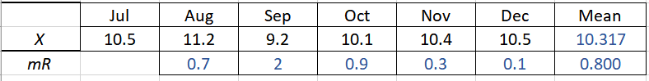
2. Compute the average trade deficit for the last half of 1988.  
   Average of Trade Deficits is *Xbar* (see #2) or 10.317.
3. Compute the Average Moving Range.  
   That would be *mR bar =* 0.8 (see #2)
4. Compute the Natural Process Limits for the X-chart using the formulas on page 60 or on page 137.  
   I assumed the Individual Moving Range, since only one data point per month. The formula for the LCL = *Xbar - (E2 * mRbar)* and for UCL = *Xbar + (E2 * mRbar)*Using constants chart, our *E2* for 2 periods because there is only 1 data point per day.  
   *LCL* = 10.317 – (2.66*0.8) = 12.445  
   *UCL* = 10.317 + (2.66*0.8) = 8.189
5. Compute the Upper Range Limit using the formula on page 60 or on page 137.  
   *UCL* = 10.317 + (1.18*0.8) = 9.373
6. Plot the *limits* from Figure 6.8 on Figure 6.10.  
   Time Series Chart  
    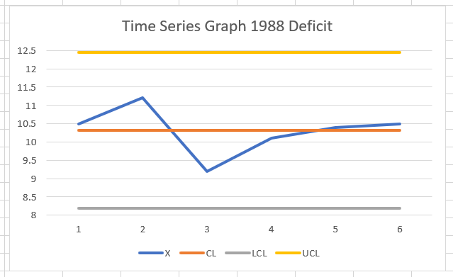  
   Moving Range Chart  
   For UCL use D4 and for LCL use D3, sample size is 1, but there is no 1 on the chart for moving range, we select n = 2 so I used D4 = 3.27 and D3 = 0.UCL for Moving Range =D4*mRbar = 3.27*0.8 = 2.616  
   LCL for moving range = D3*mRbar = 0*0.8 = 0  
   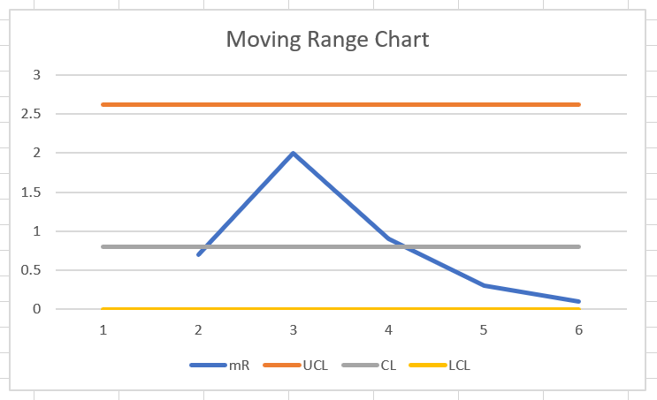
7. The U.S. Trade Deficits for the first half of 1989 are shown on the next page in Figure 6.9. Plot these values and their moving ranges on the form given in Figure 6.10.

|  |  |  |  |  |  |  |
| --- | --- | --- | --- | --- | --- | --- |
|  | Jan | Feb | Mar | Apr | May | Jun |
| 1989 | 8.7 | 8.7 | 7.0 | 6.8 | 9.6 | 9.0 |

Graph time series graph for these values with month on bottom and trade deficits for y value

|  |  |  |  |  |  |  |  |
| --- | --- | --- | --- | --- | --- | --- | --- |
|  | Jan | Feb | Mar | Apr | May | Jun | Mean |
| *X* | 8.7 | 8.7 | 7.0 | 6.8 | 9.6 | 9.0 | 8.3 |
| *mR* | 1.8* | 0 | 1.7 | 0.2 | 2.8 | 0.6 | 1.42 |

* Used the value from December 1989 to calculate moving range for Jan 1988  
Time Series Graph

Used LCL = 8.3-(2.66*1.42)=4.523 and   
UCL = 8.3+(2.66*1.42)=12.077  
CL = 8.3

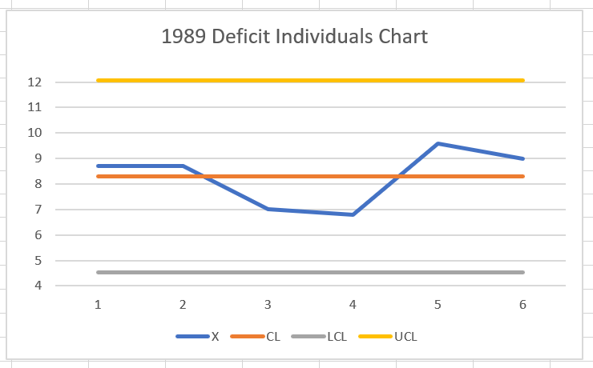

Moving Ranges Graph

Used LCL = 0*1.42= 0  
UCL = 3.27*1.42=4.643  
CL = 1.42

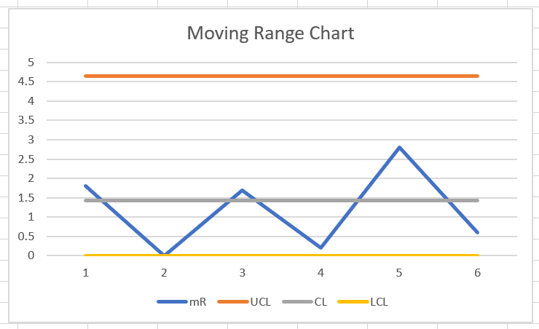

There are two indications of shifts in Figure 6.10. The first shift was favorable, and the second was unfavorable.

1. What was this favorable shift *detected*?  
   In May, there was a favorable shift.
2. When might this favorable shit have begun?  
   During the month of April.
3. When is the unfavorable shift detected?  
   February through April.